
Greenwood College
Pathway 2 –Year 8-2018
Investigation 1 – In class

NAME: _____________________ MARK: ____/30 = _______%

CALCULATORS ALLOWED: Mobile phones are to be placed in bags at the front of the classroom.
Smooth fractions – Validation in class- Part 1
Paris’ brother, Michael, and his friend, Kevin, join Nikki, Jenna and Paris at Nikki’s house. Everyone wants a ‘Power Smoothie’. The ingredients Paris needs for 1 serve are listed below.

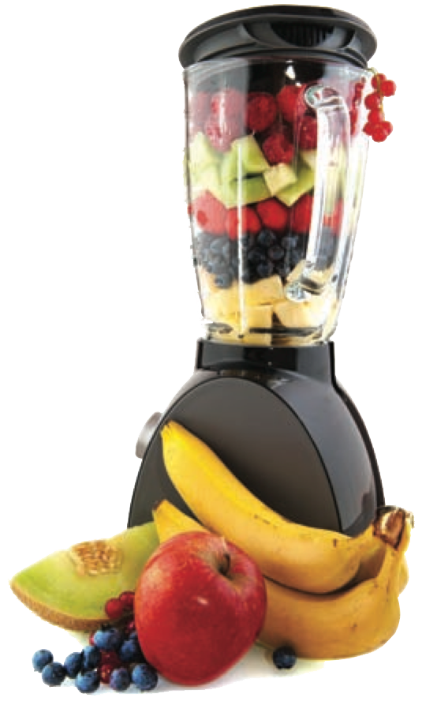

Calculate the amount of each ingredient required to make two Power Smoothies for Michael and Kevin. Include units in all your answers. (7 marks)
Recipe: Power smoothie

Serves 1 person

- 1½ bananas
- 1¾ tablespoons skim milk powder
- 1¼ cups milk

- $\frac{2}{3}$ tablespoons honey

- $\frac{1}{3}$ cup thick yoghurt

_______________________________________________________________________________________________________________________________________________________________________________________________________________
2. Find the amount of each ingredient needed to make Power Smoothies for all the people at Nikki’s house. Include units in all your answers. (8 marks)

______________________________________________________________________________________________________________________________________________________________________________________________________________________________
Fractions on the farm – part 2 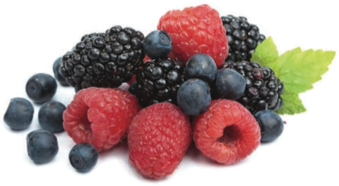

- Raspberries are collected and placed in 18 kg boxes.
They are then packed into ¾ kg punnets or 1¼ kg punnets.
How many of the following sized punnets can be packed from the 18 kg box of
raspberries? (4 marks)
a) ¾ kg ___________________ b 1¼ kg ___________________

4 a) Which sized punnet results in raspberries being left over in the box?
_____________________________________________________(2 marks)
- How many kilograms are left? _____________________________(2 marks)

The next day, James and Jenny collect blueberries and placed them in a box.
They then packed them into ¾ kg punnets.
When finished, they had 18 punnets and ½ kg of blueberries left in the box.

5. How many kilograms of blueberries did the box hold?
_____________________________________________________________________(3 marks)
6. Could they pack this amount (answer of Question 5) of blueberries into ½ kg punnets without any left overs? Explain your answer.
_____________________________________________________________________
__________________________________________________________(2 marks)
7. Could they pack this amount (answer of Question 5) of blueberries evenly into 1¼ kg punnets? Explain your answer.
_____________________________________________________________________________________________________________________

__________________________________________________________________________________________________(2 marks)

THE END

